Homework: Operating Systems
Problems for homework for the "Software Technologies" course @ Software University
Submit this document as your homework.

Work with Task Manager in Windows
- View processes:
  - Open Task Manager and view the list of running processes.
  - Identify any processes that are using a high amount of CPU or RAM.

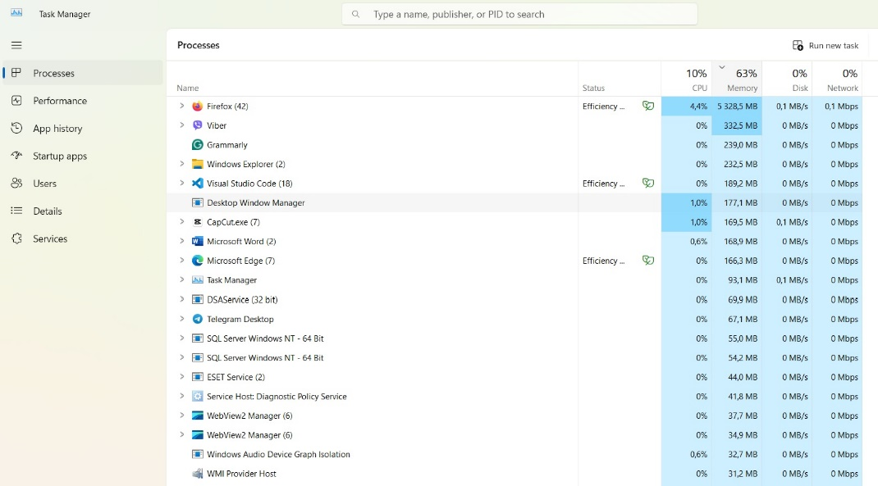

- Kill a process:
  - Select a process from the list and end the task.
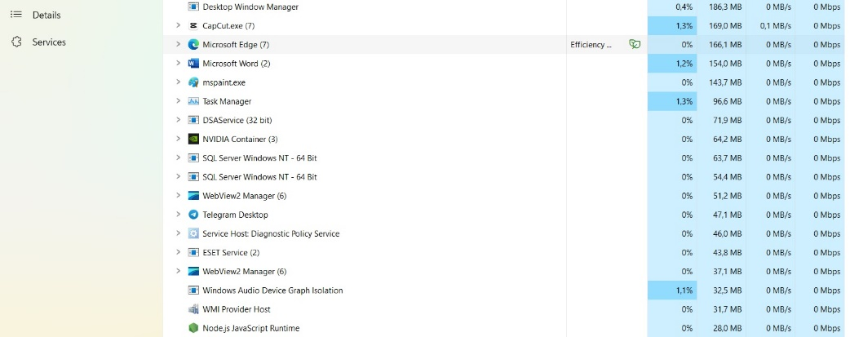

- View CPU & RAM usage:
  - Navigate to the Performance tab in Task Manager and view the CPU & Memory usage.
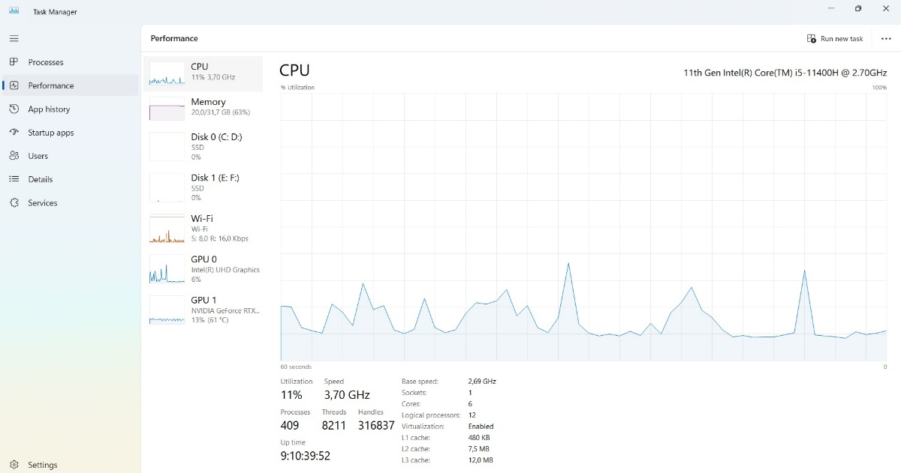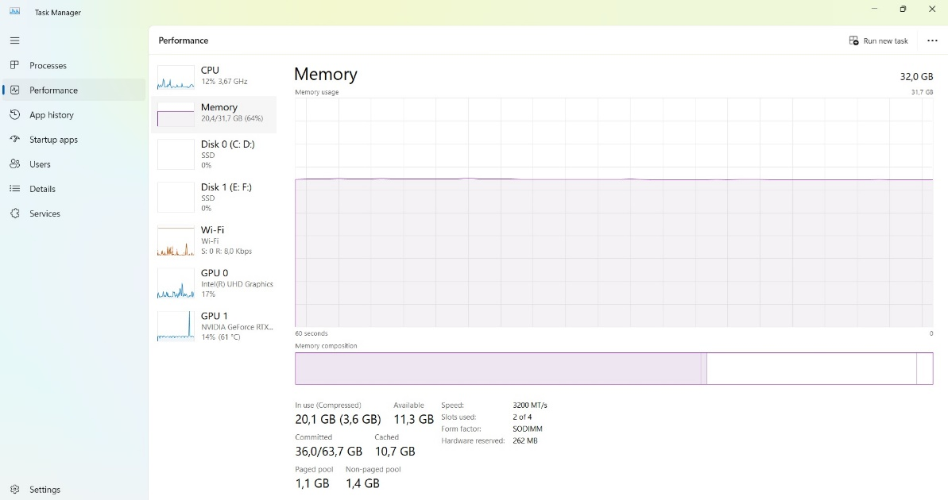

- Replace all pictures with screenshots from your PC.

Play with Windows Terminal
- Navigate Directories:
  - Use the "cd" command to navigate to different directories in the Windows Terminal:
    - Desktop
    - Documents
    - Downloads
  - Example (make screenshots of all three directories):

  - Create folder named My_SoftUni_Repo on the Desktop through the Terminal.
  - Example:
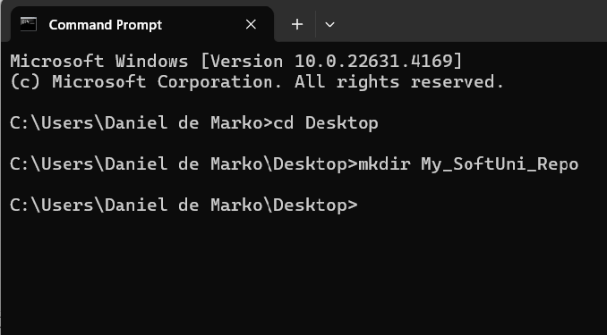
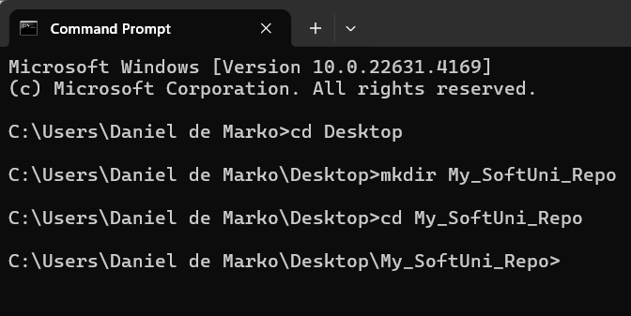
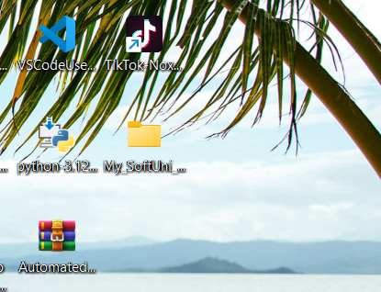
  - Enter the created folder through the Terminal and make a screenshot:

- Replace all pictures with screenshots from your PC.

Play with Docker Playground & Run a Linux Shell inside
- Run your own container in Docker Playground and make an HTTP request from Linux Shell:
  - Your task is to run a new docker container and make an HTTP request to the following API: https://api.zippopotam.us/
  - Extend the URL with "de" for Germany, and find a valid postal code that you can use to extract information from the API.
  - Replace the example images with your own screenshots.
  - Examples:
  - 